Parish of St Alban, Martyr & St Mark the Evangelist, Southend
We pray for the church around the world: Especially those who are persecuted for their faith. We pray for compassion and kindness, inclusion and love for all. We pray for all who have not yet let Jesus into their lives.

We pray for our world: All the casualties of war and conflict; victims of natural or manmade disasters; those who are living in poverty or under oppressive regimes; for all who have no safe place o live in. For the earth and all the damage done to it by humankind. For more empathy and compassion. For all who are caught up in war and conflict at this time. For all who are marginalised.

We pray for our local community [12: Market Pl, Royal Terrace][ 13: Clifton Mews, Clifftown Parade] [14: Forum, Southend Central Station] [15: LGBTQI* +community, Sam our chaplain, the future of The Cliff, Pride] [16: Scratton Rd, Clifftown Rd][17: Weston Rd, Clarence St] [18: Clarence Rd, Alexandra St]
We pray for all on our long-term list.
Prayers for all sick in hospitals, hospices, care homes and at home. For those who are caring for them. For all sick or in need: Margaret, Mark, Terry, Valerie, Tony, Kat, Judith, Rosetta, Jean Wren, Diana, Sarah, Gabby, Ann and Terry, Gary, June and Sally Binks, Rosie, Clare, Corbin, John Bulley, John Collier, Rena, Pixie

Recently departed:

In Memoriam: July. David Marr 5/7, Nicky Parks 9/7, Andrew McKechan 12/7, Vivienne Huxter 13/7, Elaine Morrison 22/7, Cian Daly 29/7

12 July 2026
Notices: Monday : Morning Prayer at 9am, Reflective Mass 1pm
Online Rosary for 100 Days of Prayer Mondays at 6pm
Pride & Other Events
Southend Pride, 18th July, march at noon from Pier Hill – Support the Inclusive Church Stall in Victoria Circus 12-5
Pride Sign Making, St Mark's, 14th July, 7pm
Rainbow Service, July 26th, doors open 2.30pm, SCBC
Fringe Week activities - find out more on Southend Pride socials - i.e. Flag Raising at Porter's House 1045
Unforced Rhythms retreat day, August 8th - sign up on Eventbrite

6th Sunday of Trinity
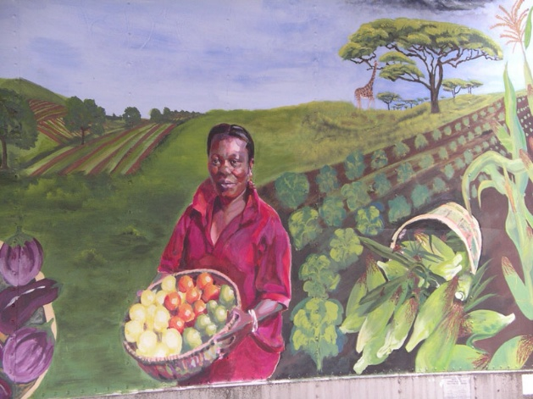
This is from a mural on the wall of an organisation called New Entry Sustainable Farming Project in Massachusetts. It features Seona ban Ngufor who was a refugee from Sierra Leone and when she found herself yearning for her farm back home the organisation helped her with training and business planning. Today, she is self sufficient and sells her organic produce at her local Farmer’s Market. Her story, and countless others, demonstrate how seeds of ideas can turn into abundant lives. Jesus is the Sower in our well known parable today. When we follow his teachings we are not gifted with a done deal but with seeds of possibility. And it is up to us to take these seeds and learn how to turn them into the most beautiful gardens for our souls.
Contact Details
Associate Priest: Mthr Cherry Sandover
revcherrysandover@gmail.com
LGBTQ+ Chaplain: Rev Sam Mackie: 07719285635
revsmackie@gmail.com

St Mark’s Website: https://www.stmarkschurchsouthend.org/

St Alban’s Website: Saint Alban the Martyr, Westcliff-on-Sea - A Church Near You

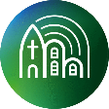
Our parish is a member of Inclusive Church. This means that we are committed to work towards being a church which celebrates and affirms every person and does not discriminate on grounds of disability, economic power, ethnicity, gender, gender identity, learning disability, mental health, neurodiversity, or sexuality. Please help us to work towards our aims.

