Parish of St Alban, Martyr & St Mark the Evangelist, Southend
27 September Trinity 17

We pray for the church around the world: Especially those who are persecuted for their faith. We pray for compassion and kindness, inclusion and love for all. We pray for all who have not yet let Jesus into their lives.

We pray for our world: All the casualties of war and conflict; victims of natural or manmade disasters; those who are living in poverty or under oppressive regimes; for all who have no safe place o live in. For the earth and all the damage done to it by humankind. For more empathy and compassion. For all who are caught up in war and conflict at this time. For all who are marginalised.

We pray for our local community: [27: Southend Care Bank; Milton Community Partnership and SAVS][28: Barons court School, all who are home-schooled] [29: Other Faith Groups in the parish][30: 10th Southend [St Mark’s Own] [1: Hamlet Rd, Princes St] [2: Ashburnham Rd, Gordon Pl][3: Gordon Rd, Napier Av]
We pray for all on our long-term list.
Prayers for all sick in hospitals, hospices, care homes and at home. For those who are caring for them. For all sick or in need: Margaret, Mark, Terry, Valerie, Tony, Kat, Judith, Jean Wren, Diana, Sarah, Gabby, Ann and Terry, Gary, June and Sally Binks, Rosie, Clare, Corbin, John Bulley, John Collier, Rena, Pixie, Steve Dart, Paul Smith, Sue Anthony.
Recently departed:
In Memoriam: Sept. Dorothy Selwood 5/9, Peter Storey 8/9, Peter Wiltshire 11/9, Jan Brown 14/9, Fr David Booth 15/9, Dorothy Simmons15/9, Edith Killmaster 18/9, Margaret Ellis 19/9

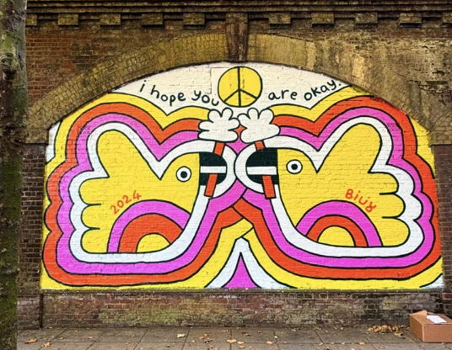
Billy Flowers I hope you are okay (The Railway Arches, Portsmouth, 2023)*
Notices: Monday : Morning Prayer at 9am, Reflective Mass 1pm
Online Rosary for 100 Days of Prayer Mondays at 6pm
Holy Hour10-11 every 3rd Sunday
New monthly Bible study course starts Sunday October 25th 1-2pm

Street Art has become much more than graffiti, as artists around the world use walls to address the many issues that create social breakdown in our towns and cities. Sometimes, the work helps to highlight as well as bring a sense of joy and value to a deprived area as we have seen with Southend City Jam. However, there is also art that draws attention with a message that acknowledges the isolation many people feel in this world of, ironically, greater interconnectedness. A simple message such as this one – I hope you are okay – is also a subtle message about war and conflict – the dove of peace transformed into a cute puffin! *billy projects
Contact Details
Associate Priest: Mthr Cherry Sandover
revcherrysandover@gmail.com

LGBTQ+ Chaplain: Rev Sam Mackie: 07719285635
revsmackie@gmail.com

St Mark’s Website: https://www.stmarkschurchsouthend.org/

St Alban’s Website: Saint Alban the Martyr, Westcliff-on-Sea - A Church Near You

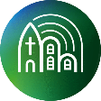
Our parish is a member of Inclusive Church. This means that we are committed to work towards being a church which celebrates and affirms every person and does not discriminate on grounds of disability, economic power, ethnicity, gender, gender identity, learning disability, mental health, neurodiversity, or sexuality. Please help us to work towards our aims.

