Parish of St Alban, Martyr & St Mark the Evangelist, Southend

2 August Trinity 9

We pray for the church around the world: Especially those who are persecuted for their faith. We pray for compassion and kindness, inclusion and love for all. We pray for all who have not yet let Jesus into their lives.
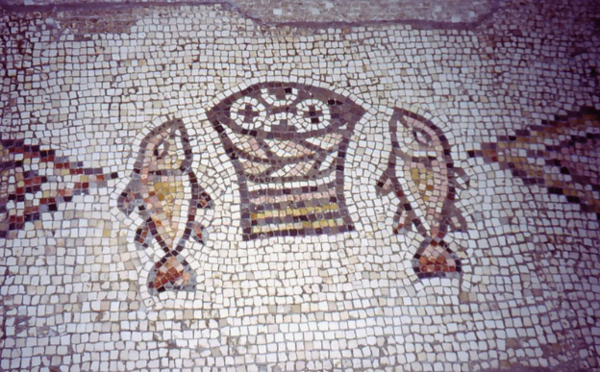
We pray for our world: All the casualties of war and conflict; victims of natural or manmade disasters; those who are living in poverty or under oppressive regimes; for all who have no safe place o live in. For the earth and all the damage done to it by humankind. For more empathy and compassion. For all who are caught up in war and conflict at this time. For all who are marginalised.

We pray for our local community: [2: Ashburnham Rd, Gordon Pl][3: Gordon Rd, Napier Av] [4: Elmer Av, Elmer Approach] [5: Luker Rd, High St] [6: Queen’s Rd, London Rd][7: College Way, Park St] [8: Park Rd, Avenue Rd, Park Lane, Parkgate]
We pray for all on our long-term list.
Prayers for all sick in hospitals, hospices, care homes and at home. For those who are caring for them. For all sick or in need: Margaret, Mark, Terry, Valerie, Tony, Kat, Judith, Jean Wren, Diana, Sarah, Gabby, Ann and Terry, Gary, June and Sally Binks, Rosie, Clare, Corbin, John Bulley, John Collier, Rena, Pixie, Steve Dart, Paul Smith.
Recently departed:
In Memoriam: August. Mary Wiggins 14/8
Mother Sheila Waring 24/8

Notices: Monday : Morning Prayer at 9am, Reflective Mass 1pm
Online Rosary for 100 Days of Prayer Mondays at 6pm
Events
Unforced Rhythms retreat day, August 8th - sign up on Eventbrite

Mosaic of Loaves and Fishes [5th century] Church of the Multiplication of Loaves and Fishes, Tagbha.
Venerable Bede speaks of the loaves and fishes in the story today in a symbolic way. He says that, by blessing the loaves, Jesus teaches us to bless our daily bread. Like the poor barley loaves and little fish, we can offer our humble human qualities to Jesus, who can bless and transform the gift of ourselves for service to others. Moral strength comes from fellowship with Jesus who offers us healing power every time we come and receive the Eucharist at Mass.
Contact Details
Associate Priest: Mthr Cherry Sandover
revcherrysandover@gmail.com

LGBTQ+ Chaplain: Rev Sam Mackie: 07719285635
revsmackie@gmail.com

St Mark’s Website: https://www.stmarkschurchsouthend.org/

St Alban’s Website: Saint Alban the Martyr, Westcliff-on-Sea - A Church Near You

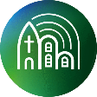
Our parish is a member of Inclusive Church. This means that we are committed to work towards being a church which celebrates and affirms every person and does not discriminate on grounds of disability, economic power, ethnicity, gender, gender identity, learning disability, mental health, neurodiversity, or sexuality. Please help us to work towards our aims.

