Parish of St Alban, Martyr & St Mark the Evangelist, Southend
11 October Harvest

We pray for the church around the world: Especially those who are persecuted for their faith. We pray for compassion and kindness, inclusion and love for all. We pray for all who have not yet let Jesus into their lives.

We pray for our world: All the casualties of war and conflict; victims of natural or manmade disasters; those who are living in poverty or under oppressive regimes; for all who have no safe place o live in. For the earth and all the damage done to it by humankind. For more empathy and compassion. For all who are caught up in war and conflict at this time. For all who are marginalised.

We pray for our local community: [11: Southend Street Pastors][12: Market Pl, Royal Terrace][13: Clifton Mews, Clifftown Parade][14: Forum, Southend Central Station][15: LGBTQI* +community, Sam our chaplain, the future of The Cliff] [16: Scratton Rd, Clifftown Rd][17: Weston Rd, Clarence St]
We pray for all on our long-term list.
Prayers for all sick in hospitals, hospices, care homes and at home. For those who are caring for them. For all sick or in need: Margaret, Mark, Terry, Valerie, Tony, Kat, Judith, Jean Wren, Diana, Sarah, Gabby, Ann and Terry, Gary, June and Sally Binks, Rosie, Clare, Corbin, John Bulley, John Collier, Rena, Pixie, Steve Dart, Paul Smith, Sue Anthony.
Recently departed:
In Memoriam: October. Ray Larner 5/10, Richard Rayner 23/10, Mikey Cartwright 25/10, Christine Isobel Lane 27/10
Notices: Monday : Morning Prayer at 9am, Reflective Mass 1pm
Online Rosary for 100 Days of Prayer Mondays at 6pm
Souper Social every 2nd Sunday after Mass
Holy Hour10-11 every 3rd Sunday
New monthly Bible study course starts Sunday October 25th 1-2pm
Rainbow Readers every 1st Sunday after Mass
LGBTQI* Art Group every 1st Wednesday 6.30pm


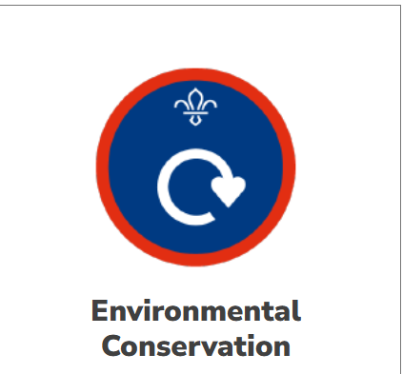
Scouts Activity Badge/Squirrels All About Adventure Challenge Award
One of the wonderful things about being a Squirrel, a Beaver, a Cub or a Scout [as well as being a leader] is the wide variety of activities that are available and how children and young people get a chance to explore ideas they may not have encountered before. As it is Harvest Festival today, I thought about how important it is that 10th Southend [St Mark’s Own] Scout Group get to experience the wonder of the natural world and learn about the need to protect it too. There are many badges and challenges that involve outdoor activities! Two of them are shown above. This helps us to practice gratitude for all we have to eat and to share generously with others less fortunate than ourselves.
Contact Details
Associate Priest: Mthr Cherry Sandover
revcherrysandover@gmail.com

LGBTQ+ Chaplain: Rev Sam Mackie: 07719285635
revsmackie@gmail.com

St Mark’s Website: https://www.stmarkschurchsouthend.org/

St Alban’s Website: Saint Alban the Martyr, Westcliff-on-Sea - A Church Near You

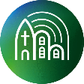
Our parish is a member of Inclusive Church. This means that we are committed to work towards being a church which celebrates and affirms every person and does not discriminate on grounds of disability, economic power, ethnicity, gender, gender identity, learning disability, mental health, neurodiversity, or sexuality. Please help us to work towards our aims.

